**Key information for making a Marketplace purchase**

You’ll take a course that trains you on Marketplace, so you should have the gist of how to navigate the program, but some of the information is lab specific. Below is a snip from the order summary with all of the information you should need to make an order.

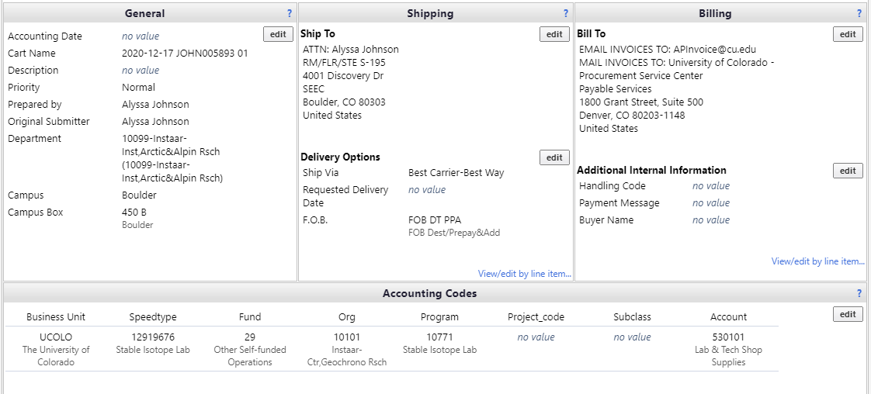

You will need to add in the speedtype and account every time you make a purchase. The other information will stay in Marketplace.

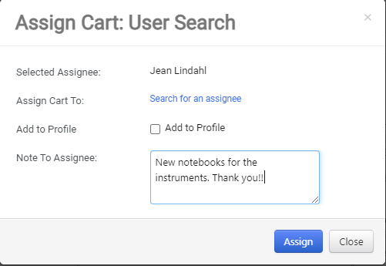

After you assign your cart (at this time our accountant is Jean Lindahl), make sure you write a quick note letting them know what the purchase is for and thanking them for their work. Then, click assign.

You’ll get an email shortly letting you know that your order was submitted for approval. If the accountant approves the purchase, you’ll get an email that says the purchase was sent to the supplier.